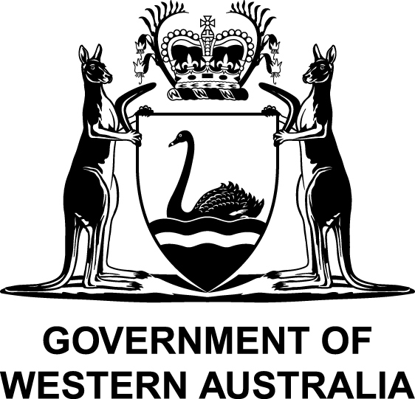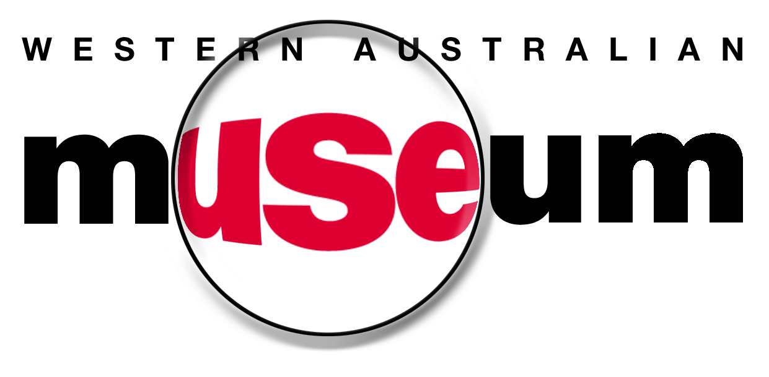

Western Australian Museum

Disability Access and Inclusion Plan 2013 – 2017

Draft

This plan is available upon request in alternative formats such as large print,
audio or Braille.

Contents

1. Background 3
1.1 The Western Australian Museum 3
1.2 Functions, facilities and services provided by the WA Museum 3
1.3 Planning for better access 4
1.4 Progress since 2007 4

2. Access and Inclusion Policy Statement 6
2.1 Policy Statement 6

3. Development of the Disability Access and Inclusion Plan 7
3.1 Responsibility for planning process 7
3.2 Review of customer complaints 7
3.2 Community consultation process 7
3.3 Findings of the Consultation 8

4. Implementing the Plan 9
4.1 Responsibility for implementation 9
4.2 Communicating the plan 9
4.3 Reviewing and reporting on the plan 10

5. Access and Inclusion Strategies 11

1. Background

1.1 The Western Australian Museum

The origins of the Western Australian Museum (the Museum) date back to 1891 when the Geological Museum was established in the old Perth gaol. It became the Western Australian Museum and Art Gallery in 1897.

The Museum and the Art Gallery became separate institutions in 1959. The Museum focussed its collecting and research interests in the areas of natural sciences, anthropology, archaeology and the State’s history. The Museum also began to work in the emerging areas of historic shipwrecks and Aboriginal site management during the 1960’s and 1970’s.

The Museum now operates as a statutory authority within the Culture and the Arts portfolio. The Museum’s enabling legislation is the Museum Act 1969. Under this legislation, the Museum is governed by a Board of seven Trustees.

1.2 Functions, facilities and services provided by the Western Australian Museum

The Museum operates six public sites at the following locations:

- WA Museum - Perth (Perth Cultural Centre, Northbridge);
- WA Maritime Museum (Victoria Quay, Fremantle);
- WA Museum - Shipwreck Galleries (Cliff Street, Fremantle);
- WA Museum - Albany (Residency Road, Albany);
- WA Museum - Geraldton (Museum Place, Geraldton);
- WA Museum - Kalgoorlie-Boulder (Hannan Street, Kalgoorlie).

The Museum maintains a collection and research centre in Welshpool which stores more than 4.5 million objects from rare artefacts to the iconic blue whale skeleton formerly displayed at the Francis Street site.

The Museum manages 200 shipwreck sites of the 1500 known to be located off the Western Australian coast. The Museum also manages eight Aboriginal land reserves.

The Museum’s mission is to: “inspire people to explore and share their identity, culture and environment and sense of place, and to experience the diversity and creativity of our world.”

The Museum’s vision is to: “provide an excellent and vibrant service, valued and used by all Western Australians and admired and visited by the World.”
The main ways in which members of the public interact with the Museum is through:

- Permanent and temporary exhibitions (onsite and touring);
- Interactive displays;
- Education activities;
- Guided tours;
- Community events; and
- Outreach activities to the wider WA community.

1.3 Planning for better access

Approximately 16% of West Australians identify themselves as having some form of disability (Australian Bureau of Statistics data, 2012).

It is a requirement of the Disability Services Act 1993 that public authorities develop and implement a Disability Access and Inclusion Plan (DAIP) that outlines the ways in which the authority will ensure that people with disabilities have equal access to its facilities and services.

Other legislation underpinning access and inclusion includes the WA Equal Opportunity Act 1984 and the Disability Discrimination Act 1992 (Commonwealth).

1.4 Progress since 2007

The Museum developed its first DAIP in 2007. Since that time, the Museum has implemented a number of initiatives to improve accessibility of Museum services including:

- Purchasing new showcases and incorporating universal access into space planning for temporary exhibitions so that Museum objects are more accessible, especially for people using wheelchairs;

- Trialling new technologies so that patrons can access Museum content in new ways;

- Introducing software that assists exhibition designers test colour contrasts and identify potential issues for colour blindness;

- Improving the lighting system in the temporary exhibition gallery at the Perth site so that Museum objects are better lit;

- Installing audio points with headphones in key exhibition spaces to allow undisturbed listening of audio commentary accompanying Museum exhibitions;

- Improving physical access to the Museum’s metropolitan and regional sites, including the installation of new ramps and universal access paths;

- Implementing major improvements to the accessibility of the Museum’s website;

- Developing new education programs specifically for students with disability;

- Incorporating the use of different senses, such as touch and smell, into Museum exhibitions to broaden their accessibility.

2. Access and Inclusion Policy Statement

2.1 Policy Statement

The Museum is committed to ensuring that all aspects of the Museum are fully accessible to all sectors of the community by removing or reducing any physical, sensory or intellectual barriers to access.

The Museum interprets fully accessible to mean that all Museum activities, facilities and services (both in-house and contracted) are open, available and usable to people with disabilities, providing them with the same opportunities, rights and responsibilities enjoyed by other people in the community.

The Museum is committed to consulting with people with disabilities, their families and carers and, where required, disability organisations to ensure that barriers to access and inclusion are addressed appropriately.

The Museum is committed to ensuring that its agents and contractors work towards the desired access and inclusion outcomes in this DAIP.

The Museum is committed to achieving the seven outcomes of its DAIP:

Outcome 1 | People with disabilities have the same opportunities as other people to access the services of, and any events organised by, the Museum.
Outcome 2 | People with disabilities have the same opportunities as other people to access the buildings and other facilities of the Museum.
Outcome 3 | People with disabilities receive information from the Museum in a format that will enable them to access the information as readily as other people.
Outcome 4 | People with disabilities receive the same level and quality of service from the staff of the Museum.
Outcome 5 | People with disabilities have the same opportunities as other people to make complaints to the Museum.
Outcome 6 | People with disabilities have the same opportunities as other people to participate in any public consultation by the Museum.
Outcome 7 | People with disabilities have the same opportunities as other people to seek employment with the Museum.

3. Development of the Disability Access and Inclusion Plan

3.1 Responsibility for planning process

The Department of Culture and the Arts coordinates a Disability Services Planning Committee comprising representation from the whole Culture and Arts Portfolio, including the Museum, as well as community representation.

Public authorities such as the Museum are required to develop their own DAIP although with feedback from the aforementioned Committee.

This new DAIP has been developed with input from key staff across the Museum.

3.2 Review of customer complaints

In 2012 the Museum reviewed complaints and comments made by patrons of the Museum over preceding years with respect to access matters. Most complaints were made in relation to the Museum’s facilities including poor internal signage, difficulty with access doors and compromised public amenities. Comment was also made in relation to the absence of audio guides for some exhibitions as well as lack of information that would assist organising tour groups to the Museum.

3.2 Community consultation process

In 2012 the Museum reviewed its existing DAIP, consulted with stakeholders and prepared a new DAIP to guide further improvements to access and inclusion.

The process included:

- Reviewing the Museum’s existing DAIP (2007 - 2011) and assessing what has been achieved over the preceding five years;
- Assessing other government agency DAIPs and access initiatives for benchmarking purposes;
- Reviewing best practice models in the Museum sector, both nationally and internationally;
- Consulting with Museum staff;
- Consulting with the wider public community.

The following actions were carried out as part of the Museum’s community consultation:

- Three public consultation sessions were organised by the Department of Culture and the Arts for all portfolio institutions, including the Museum. These sessions were held on:
- 30 July 2012 (Fremantle);
- 1 August 2012 (Perth); and
- 8 August 2012 (Midvale).

- These consultation sessions were publicised by the Department through a newspaper advertisement placed in “The West Australian” and seventeen community newspapers in the metropolitan area, via email notification to stakeholder groups, via social media and by placing information on the websites of portfolio institutions. There were 27 participants for these public consultation sessions.

- The Museum also conducted an online survey to inform its new DAIP. The Museum invited participation for this survey via email notification to stakeholder groups, via social media and by information placed on the websites of the Museum and the Commissioner for Children and Young People. There were 23 responses to the online survey.

3.3 Findings of the Consultation

The consultation showed that while the Museum has introduced some worthwhile initiatives to improve accessibility, there remains a range of access barriers that require redress. Key issues that emerged from the consultation included the need for:

- Broad and representative consultation with people with disabilities, their families and carers when developing new programs.

- Developing programs for specific audiences and for the Museum to provide supported tours, events and activities.

- Exhibitions to be suitable for people with different types of disability.

- Improvements to the physical infrastructure and environment within Museum facilities, as well as access to facilities;

- New Museum facilities to address universal access not only in initial planning but through to construction and final delivery.

- Information to be available (on websites, in promotional material) to support planning for visits to Museum facilities.

- Disability awareness training for all staff and for such training to be provided on an ongoing basis.

4. Implementing the Plan

4.1 Responsibility for implementation

The Disability Services Act 1993 requires staff and the agents and contractors of the Museum to conduct their business in a manner consistent with the Museum’s DAIP. Areas of responsibility are:

Executive Management Team
It is the responsibility of the Museum’s Executive Management Team to:

- Agree on annual implementation plans for the DAIP;
- Support implementation plans through the provision of resources; and
- Advocate for improved access to Museum facilities and services both internally within the Museum and externally to other organisations and bodies as appropriate.

Museum Staff
Implementation of the DAIP is the responsibility of all staff at the Museum. Some initiatives in annual implementation plans will apply to all areas of the Museum while others will apply to specific directorates. The implementation plans will set out who is responsible for each initiative.

Designated Officer
The Executive Management Team will nominate a Museum staff member who will have responsibility for:

- Developing annual implementation plans for the DAIP in consultation with other staff,
- Monitoring, evaluating and reviewing implementation tasks;
- Representing the Museum on the Department of Culture and Arts Disabilities Services Planning Committee; and
- Coordinating annual reporting requirements and related matters.

Contractors
It is the responsibility of agents and contractors of the Museum to ensure that any work or service they conduct on behalf of the Museum is consistent with the Museum’s DAIP.

4.2 Communicating the plan

The Museum’s DAIP will be available on the Museum’s website. Copies of the DAIP will be available in alternative formats and languages upon request.

Annual implementation plans will be available to staff on the Museum intranet. A broadcast email will be sent to all staff when new implementation plans are issued.

4.3 Reviewing and reporting on the plan

The Museum will review progress against the DAIP strategies and undertake to develop a new DAIP by July 2017.

The Museum will annually:

- Review progress in completing tasks identified in the implementation plan; and
- Develop a new implementation plan.

The Museum will meet the requirements of the Disability Services Act 1993 for minimum reporting requirements by:

- Monitoring tasks undertaken in the implementation plans;
- Reporting annually to the Museum’s Executive Management Team on progress in implementing tasks;
- Reporting by the 31 July annually to the Disabilities Services Commission on progress in implementing DAIP strategies, including those carried out by agents and contractors; and
- Reporting on progress of DAIP implementation in the Museum’s Annual Report.

5. Access and Inclusion Strategies

The following overarching strategies will guide tasks, reflected in annual implementation plans, that the Museum will undertake from 2013 – 2017 to improve access to its services, buildings and information.

Outcome 1: People with disabilities have the same opportunities as other people to access the services of, and any events organised by the WA Museum.
Strategies
Develop and implement public programs and activities so that they meet the needs of people with disabilities.
Ensure universal access is fundamental to the planning, design and installation of Museum exhibitions.
Ensure Museum events are accessible to people with disabilities, including those held in non-Museum facilities.
Explore new and creative ways of delivering Museum experiences so that they are accessible to people with disabilities.
Actively encourage participation in Museum programs, exhibitions, events, and other activities by people with disabilities, their families and carers.

Outcome 2: People with disabilities have the same opportunities as other people to access the buildings and other facilities of the WA Museum.
Strategies
Improve the accessibility and ease of use of Museum buildings and facilities so that they meet the needs of people with disabilities, their families and carers.
Ensure that planning, design, construction and delivery of new Museum facilities comprehensively address universal access requirements.
Work cooperatively with public authorities to ensure adjacent facilities, such as for parking and amenities, meet the needs of people with disabilities.

Outcome 3: People with disabilities receive information from the WA Museum in a format that will enable them to access the information as readily as other people.
Strategies
Ensure all information provided by the Museum to the public complies with the State Government Access Guidelines for Information, Services and Facilities.
Ensure information is available that allows people with disabilities, their families and carers to plan for visits to Museum programs, exhibitions, events, and other activities, whether held at Museum or non-Museum facilities.
Provide alternative formats for Museum information, upon request.

Outcome 4: People with disabilities receive the same level and quality of service from the staff of the WA Museum.
Strategies
Ensure all staff have the knowledge and skills to provide quality services for people with disabilities, their families and carers.

Outcome 5: People with disabilities have the same opportunities as other people to make complaints to the WA Museum.
Strategies
Ensure that complaint mechanisms are accessible for people with disabilities and that complaints can be made in a flexible manner.

Outcome 6: People with disabilities have the same opportunities as other people to participate in any public consultation by the WA Museum.
Strategies
Ensure all public consultation by, or on behalf of, the Museum is conducted in an inclusive and accessible manner.
Establish and convene an advisory group that provides guidance on improving Museum access and inclusion for people with disabilities, their families and carers, including for New Museum activity.

Outcome 7: People with disabilities have the same opportunities as other people to seek employment with the Museum.
Strategies
Ensure recruitment practices are inclusive and align with Departmental requirements and expectations.
Ensure that Museum staff with disabilities are supported appropriately so they can undertake their employment responsibilities.

