STABILIZATION OF CORRODED ALUMINIUM: the Bertram seaplane float.

Dr lan D. MacLeod

Ian MacLeod, born 1948. Undergraduate studies at the University of Melbourne (B.Sc. 1971); doctoral thesis on the electrochemistry of metal fluorides in anhydrous hydrogen fluoride at the University of Melbourne (Ph.D. 1974); research fellow in chemistry, University of Glasgow, 1974-75; post-doctoral fellow at Murdoch University (Perth, W.A.) 1976-78, working on copper electrochemistry. At the time of writing this article he was Research Officer, Conservation Department, Western Australian Museum, from October 1978. Since then he has been Head of Department and a Director of the Museum. Author's address: Department of Material Conservation and Restoration, W.A. Museum, Cliff Street, Fremantle, Western
Australia 6160.

EMAIL: ian.macleod@museum.wa.gov.au

Abstract-A simple washing procedure has been developed for stabilization of corroding aluminium-copper alloys. The use of an ammonia-ammonium sulphate buffer at pH 9.6 in aerated deionized water effectively removes cemented copper metal and copper corrosion products from the surface of the object whilst also removing aggressive chloride ions. This treatment has been used to stabilize a Duralumin sea-plane float which was actively corroding after 46 years’ exposure to a marine environment.

1 Introduction

At the time of writing, little or no information is readily available to the conservator faced with the problem of how to treat a corroding modern alloy such as aluminium. For transport and other museums whose collections include aeroplanes and automobiles this dearth of information can be of major concern. The problem will be exacerbated as contemporary vehicles, motors, etc., are added to the collections.
This paper describes the treatment used to stabilize a large corroded Duralumin sea-plane float from a Junkers W33 aircraft which was abandoned by H. Bertram, at Cape Bernier (14°00'S, 127°27'E) in 1932. The aircraft had been on a flight from Koepang (Timor) to Darwin when various circumstances caused it to land hundreds of miles off course in a most inhospitable part of tropical N.W. Australia [1]. The abandoned float had been used as a sailing vessel in an attempt by the crew to reach safety. The ‘Atlantis’ float was discovered in 1978 by members of a W.A. Museum expedition and sent to the conservation laboratories in Fremantle for treatment.

2 Description of float

When the float was uncrated at the conservation laboratories after a 3000km journey it was immediately obvious that it had suffered extensive pitting corrosion after being exposed for 46 years in a littoral location. There was evidence of continuing corrosion underneath the red-brown surface coating of pindan, a characteristic mixture of red clay soils of the Kimberley region which have been cemented together with large amounts of sand and some calcium minerals. Large areas were covered with the original tar-like paint and often the concreted sands, tar and metal corrosion products were the only materials that gave form to parts of the float. The major corrosion products detected were aluminium hydroxide (Gibbsite, Al(OH)₃) and an unidentifiable light blue copper-containing material which had a distorted alumina structure. The major calcium mineral was gypsum, CaSO₄ ·2H₂0, and there were minor amounts of calcite, CaCO₃.

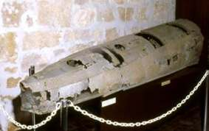

Figure 1 Tthe Duralumin seaplane float from the Junkers W33 when first displayed, showing
extensive corrosion after 46 years' exposure to salt air.

The float was approximately 3·75m long, 0·84m wide and 0·8m high at the tail end while tapering to 0·11m diameter near the nose (see Figure 1) and although it weighed only 15kg the overall size required a large tank for any washing treatment. The float was originally constructed with a series of eight bulkheads to form nine watertight compartments. All of the bulkheads had been perforated by corrosion and a large amount of loosely concreted sand was found in the bottom of the vessel. A registration disc no. 49754T was found near the nose of the float. Several metal panels were held to the frame by mounds of corrosion products which had previously been rivets; even a slight movement caused more panels to become detached. After removal of the worst of the loose sand by low pressure water and gentle cleaning with a nylon bristle brush, the major source of the pitting corrosion reactions was revealed. Patches of metallic copper were found on the surface of the metal and this is known to cause a marked increase in the aluminium corrosion rate.

3 Aluminium corrosion

The highly reactive nature of aluminium metal is normally masked by the protective oxide film which readily forms in moist air and renders the metal kinetically stable. The reactivity of the metal and the refractory nature of the oxide helped delay the first commercial production of aluminium until 1886. The addition of small amounts of alloying elements can greatly increase the mechanical strength of the metal while having a negligible effect on the density. For example the addition of 4% copper increases the stress load capacity of aluminium by 85% [2]. Because of the increased mechanical strength and light weight of such alloys, materials such as Duralumin (3-5% copper, 0·3-0·6% magnesium and 0·4-1·0% manganese) have been used in the aircraft industry. The main metal used in the 'Atlantis' sea-plane float had the composition 92.8% aluminium, 4·12% copper, 0·44% magnesium, 0·31% iron, 0·77% manganese and 0·03% lead and thus falls into the composition range for Duralumin.
Although the addition of copper increases the strength of aluminium it dramatically decreases the corrosion resistance of the metal to seawater. Without a protective paint film such alloys suffer severe pitting, e.g. perforation of a 6·4mm plate in a few years [3]. Copper has a limited solubility in aluminium (2wt%) and unless the liquid metal is rapidly cooled copper will not be uniformly distributed throughout the grains of the aluminium phase [4]. If precipitation hardening (increase in hardness of the metal due to the precipitation of the CuAl₂ inter-metallic phase) occurs, the areas around the grain boundaries become depleted in copper and as such become more anodic (more reactive) than the rest of the grain. Under these conditions the metal is subject to inter-granular corrosion. Metallographic analysis of polished sections from the ‘Atlantis’ float showed up a network of CuAl₂ units and a small amount of inter-granular corrosion. In the absence of complicating factors the more reactive metal or

Table 1

Solid solution or constituent E_{corr}, the corrosion potential
Volts rel. N.H.E., 25°C

Cu +0·07 noble
Al + 4% Cu in solid solution -0·36
CuAl₂ -0·40
Al + 2% Cu in solid solution -0·42
Al -0·52 active

Data for corrosion potential in seawater from [3].
Corrosion potentials for a solution containing 53g 1⁻¹ NaCl, 3g 1⁻¹ H₂0₂ from [4].

metal phase will have a more negative corrosion potential (see Table 1). The difference of 100mV in the E_{corr} values for pure aluminium and aluminium with 2% copper in solid solution is quite large and can lead to markedly different corrosion rates across the different phases in a sheet of metal.
The most severe form of corrosion found on the float was due to pitting. Under mounds of corrosion products consisting of sand grains (silica, zircon), aluminium hydroxide (Gibbsite, Al(OH)₃) and a blue copper corrosion product were patches of very thin layers of elemental copper (see Figure 2). The copper metal had been redeposited from the surrounding copper corrosion products. The copper corrosion products were formed by the oxidation of the CuAl₂ units in the metal structure. A very common mineral formed during the corrosion of copper in seawater (pH 8·2) is cuprous oxide (Cu₂O). Under the same conditions an aluminium oxide (Al₂0₃) will form as aluminium corrodes. Because of the more reactive nature of aluminium compared with copper, Cu₂0 or any other copper mineral can be converted back to the metal by reaction with aluminium metal,
2A1 + 3Cu₂0 → A1₂0₃ + 6Cu (1)

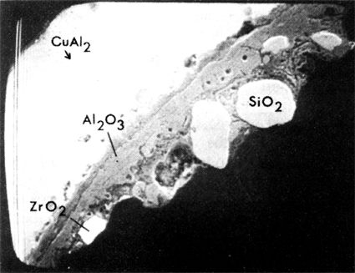
Figure 2 Scanning electron micrograph of a mounted section of corroded Duralumin from the ‘Atlantis’ seaplane float. The white spots in the metal are CuAl₂ units, the dark grey material adjacent to the metal is a mixture of aluminium corrosion products and calcium minerals.

The formal cell potential for the above reaction is +1·98 volts and so the process is spontaneous. Examination of the Pourbaix diagram (E_{h} vs pH) for copper in seawater [5] and for aluminium [6] shows that none of the copper corrosion products can coexist in contact with aluminium metal under equilibrium conditions. In the light of this it is not surprising to find that copper had deposited on parts of the aluminium surface.

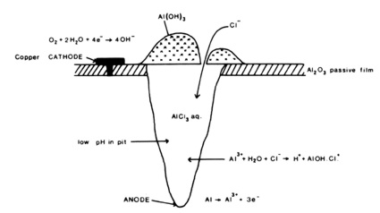

Figure 3 Schematic diagram showing pitting corrosion in aluminium.

In the pitting of aluminium (see Figure 3) the deposited copper acts as a cathodic site for the facile reduction of oxygen [7], viz.
0₂ + 2H₂0 + 4e → 40H⁻ (2)
Noble impurities such as Al₃Fe act in a similar fashion. Chloride ions are known to be absorbed onto aluminium [8] and as little as 15ppm chloride can initiate pit growth due to breakdown of the protective oxide film [9].
The anodic reaction occurs at the bottom of the pit
Al → Al³⁺ + 3e (3)
and the aluminium ions migrate towards the interfacial region where hydrolysis occurs,
Al³⁺ + 3H₂0 → Al(OH)₃ + 3H⁺ (4)
which makes the pit acidic. Chloride ions migrate into the pit to form aluminium chloride (A1Cl₃) which dissolves in the solution. Because of the low pH the aluminium may also corrode with the evolution of hydrogen [9].
2A1 + 6H⁺ → 3H₂ + 2A1³⁺ (5)
There is a critical bulk chloride concentration needed to keep the pit propagating (1·6M) which is higher than normal seawater (0·57M) but this level could be easily reached through evaporative concentration since the float was exposed to salt spray on the shoreline. Metallographic analysis of what appeared to be sound metal on the ‘Atlantis’ float revealed deep pits which had penetrated 150μm into the metal which was originally 500μm thick. The extent of the overall corrosion problem was revealed in a detailed inspection of the float which showed that up to 60% of the surface skin and structural members had severe pitting and perforation.
There is an equilibrium between the formation of aluminium oxide and AlCl₃, at the interfacial region (the area between the metal and the corrosive medium) viz.
A1₂0₃ + 6H⁺ + 6Cl⁻ ←→ 2AlCl₃ aq + 3H₂0 (6)

When aluminium chloride is formed a pit develops and when alumina (Al₂0₃) forms the pit will passivate. The chloride ions directly affect the corrosion potential of aluminium in fresh water [9]. The higher the chloride ion concentration the more negative is the corrosion potential and the faster the metal will corrode (in the absence of complicating factors). Chloride ions accelerate the corrosion process but whether this is due to oxide film breakdown or assisting the anodic reaction is not known [8]. To be effective in arresting further corrosion the treatment process must remove the re-deposited copper from the remaining metal surface and also remove chloride ions.

4 Ammonia leaching treatment

The float was cleaned of loose sand by the action of a stiff nylon bristle brush and water before being placed in a tank (3100 litres capacity) filled with de-ionized water. The chloride and copper concentrations in the wash solutions were measured once a week throughout the treatment period and measurements of pH, E_{h} of the solution and E_{corr} of the metal were made at the same time. After three weeks' washing in de-ionized water, 50kg of ammonium sulphate and 50 litres of 0·880 ammonia were added to the solution which gave a pH of 9·6 ± 0·1. The formal concentrations in the above wash were 0·125M (NH₄)₂SO₄ and 0·25M NH₃. After 80 days in this solution the float was removed and inspected for signs of corrosion and was scrubbed down once more with a bristle brush before being placed in a fresh ammonia/ammonium sulphate solution. The second wash lasted for 143 days before the scrubbing and solution-changing procedure was repeated. The final wash lasted for a further 178 days after which the float was removed from the tank and dried in air. The final concentrations in the wash were 2ppm copper and 21ppm chloride. Any adventitious iron stains on the aluminium surface were removed by brushing with a solution containing 5wt% oxalic acid and 5wt% EDTA. The float has shown no signs of further deterioration over a period of four months since the treatment was finished. Chloride concentrations were determined using the Buchler-Cotlove chloridometer and copper was determined by atomic absorption spectroscopy.
Some sections of the float were riveted together with a layer of canvas between them prior to waterproofing with pitch. The material was bound into a solid mass of copper and aluminium corrosion products held together by pindan and general calcareous concretions. The fabric was cleaned by soaking in a solution containing 0·4M NH₃, 0·2M (NH₄)₂SO₄ and 0·5wt% of the di-sodium salt of EDTA for three months. The canvas was periodically washed in de-ionized water between layers of fibreglass gauze to remove any loosened minerals.

5 Discussion

Having established the corrosion mechanism for aluminium-copper alloys in the presence of chloride ions it became apparent that the metallic copper and the chlorides in the float should be removed to prevent any further deterioration.
The ammonia/ammonium sulphate wash-solution was chosen because the combined effect of ammonia and oxygen dissolves copper(II) corrosion products and any copper metal on the surface of the float. The same reactions are used at elevated temperatures and pressures in hydrometallurgical processes [10]. The protective aluminium oxide film is normally stable over the pH range of 4·7 to 9·7 [11]; at lower pH the film dissolves as A1³⁺ ions while at high pH the soluble aluminate (A10₂⁻) ion is formed. Although the pH of 9·6 ± 0·1 established by the ammonium sulphate/ammonia buffer system is moderately high for the stability of the aluminium surface film, it has been found [12] that such solutions do not actively corrode aluminium; thus sound Duralumin would not be adversely affected by the wash.
The dissolution reaction for the surface copper metal can be written as
Cu + 4NH₃ + ½0₂ + H₂0 → Cu(NH₃)₄²⁻ + 20H⁻ (7)
Apart from functioning as a pH buffer the ammonium ion can also speed up the oxidation process in the following manner
Cu + ½0₂ + 2NH₃ + 2NH₄⁺ → Cu(NH₃)₄²⁺ + H₂0 (8)
The copper (II) tetramine ion can also act as an oxidant and can dissolve the surface copper metal,
Cu + Cu(NH₃)₄²⁺ → 2Cu(NH₃)₂⁺ (9)
to form the copper(l) amine complex which is rapidly oxidized by atmospheric oxygen to the Cu(NH₃)₄²⁺ ion. A relatively high initial surface concentration of Cu(NH₃)₄²⁺ ions results from the rapid dissolution of the copper(II) corrosion products. The range of stability of the amine complexes of copper(II) and copper(I) can be seen in the combined E_{h}-pH diagram for copper and aluminium in water as shown in Figure 4. The hatched area refers to the experimentally observed range of pH and E_{h}. The most positive voltages (0.28 volts) refer to the solution potential, measured at a platinum electrode, and indicate that the copper tetramine ion is the stable form of copper in the oxygenated wash-solution. The presence of the Cu(NH₃)₄²⁺ ion was confirmed by the intense blue colour and its UV-visible spectrum. The most negative potentials, -0·4 volts, refer to the corrosion potential of the metal float; under the conditions found in the wash solution it is unlikely that any fresh pits can occur [9]. The potentials measured on the surface of the float, -0·2 to +0·1 volt, were in the stability range for the copper(l) diamine ion. According to the Pourbaix diagram in Figure 4 any copper amine complexes could be reduced back to copper by aluminium metal if the oxygen (E_{h}) concentration was low. In practice this does not occur because of the combined effects of the pH of the wash solution which tends to ‘repair’ flaws in the oxide film, the low chloride concentration and the kinetic (energy) barriers associated with the cementation reaction.
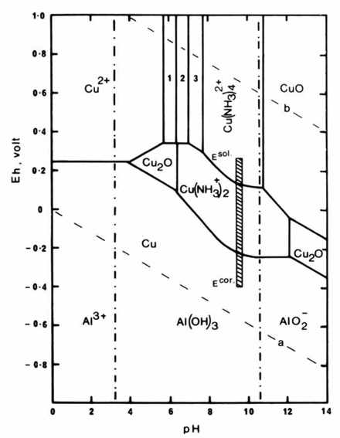
Figure 4 Potential-pH diagram for the system Cu-NH₃-Cl-H₂O-Al. The diagram is based on data from [6] and [14]. Region 1 is the stability domain for Cu(NH₃)₁²⁺ region 2 for Cu(NH₃)₂²⁺ and region 3 for Cu(NH₃)₃²⁺. Solution conditions are NH₃ = NH₄ = 0·25M, Cl = 2 X 10⁻³M, Al = 10⁻⁶M, CU = 1 X 10⁻⁴M.

The data summarizing the copper and chloride release rates are shown in Figure 5 and Table 2. During the wash in deionized water no copper went into solution but the chloride release was linear when plotted against square root of the time (t^{½}) which suggests that the release is a diffusion-controlled process [13]. After addition of the

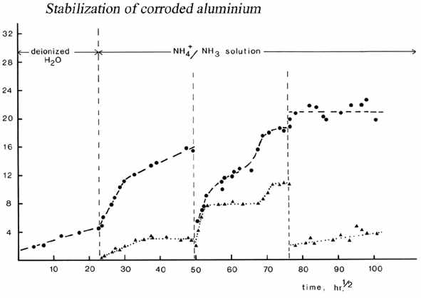
Figure 5 Plot of copper and chloride concentrations in the wash solutions for the ‘Atlantis’ seaplane float versus the square root of the treatment time. Solution volume approx. 3100 litres.

Table 2 Release rates of copper and chloride ions during treatment of the ‘Atlantis’ seaplane float. The wash solution was 0·125M (NH₄)₂SO₄, 0·25M NH₃ unless otherwise stated.

Time interval Chloride release Copper release
hr^{½} ppm hr^{-½} ppm hr^{-½}
0-23 0·16 ± 0·02ª 0·00 ± 0·03
23-32 1·00 ± 0·03^{b} 0·30 ± 0·02
32-50 0·37 ± 0·05 0·00 ± 0·03
50-53 1·1 ± 0·03^{c} 1·9 ± 0·3
53-66 0·30 ± 0·04 0·00 ± 0·03
66-72 1·2 ± 0·3 0·9 ± 0·03
77-101 — 0·07 ± 0·02^{d}

- Solution containing only deionized water.
- Addition of ammonia and ammonium sulphate.
c) Fresh NH₄⁺/NH₃ solution after scrubbing float.
d) Fresh NH₄⁺/NH₃ solution after scrubbing float after second wash

ammonia and ammonium sulphate, copper began appearing in the solution and the chloride release rate increased by more than six times (see Table 2). Both processes initially showed a linear increase in solution concentration when plotted against t^{½}, but then the copper release slowly stopped while the chloride release rate fell to a steady and non-zero value which was roughly double the initial rate observed in deionized water. A reasonable interpretation of the above behaviour is that there are two modes of chloride release, both of which are diffusion controlled, but only one is associated with the dissolution of the surface copper and the copper corrosion products.
The wash solution was changed after 14 weeks and the float was brushed down. At this stage a significant amount of the blue corrosion products had been removed from the surface of the float and more of the red-brown pindan material came off with brushing. In the first two weeks of the new wash (50<t^{½}<53) there was a marked increase in copper and chloride concentrations before the copper concentration reached a plateau at 8ppm, and the chloride increase fell off to essentially the same value it had during the first wash copper-plateau region. After two months the copper concentration increased above the plateau level for one month before reaching a new plateau at 1lppm. There was a concomitant increase in the chloride release rate above the steady value of 0·3 to 1·2ppm.hr^{-½} during the monthly interval 66<t^{½}<72 (see Table 2). During the second wash in ammonia/ammonium sulphate the initial increase in both copper and chloride release rates was probably due to the removal of a combination of pindan, hydrolysis products and some bituminous paint from the surface of the float when it was scrubbed down with a bristle brush. The second increase in the copper release rate after two months of being static is probably due to effective penetration of the leaching solution into deeper layers of corrosion products. The copper and chloride concentrations remained steady at l1ppm and 19ppm for one month before the solution was changed and the float was scrubbed down once more. At this stage of the treatment virtually all signs of the blue copper corrosion products had disappeared from the surface of the float. The high initial chloride level in the fresh water solution, approximately 20ppm, was due to the use of impure deionized water and this tended to mask anything but a major increase in chloride concentration. The copper release rate was very slow during the six months of the wash and gave a final value of 3·8ppm copper in the solution. The float was removed from the tank after a total of 425 days treatment. After four months of storage in air under ambient conditions there is no sign of any deterioration.
During the first two ammonia/ammonium sulphate washes the chloride release rate fits into two distinct zones. When copper is not being released (plateau regions) that rate is approximately 0·3ppm.hr^{-½} and when there is a linear increase (vs.t^{-½}) of copper the chloride release rate is approximately 1·0ppm.hr^{-½}. The three-fold difference in release rate is statistically significant. The initial chloride release rate in de-ionized water is half that found in the ammonia wash-solution and this may be due to the difference of approximately 3 pH-units between the two solutions changing the rate of hydrolysis reactions. Insufficient data exist to determine the precise nature of the variations in the copper release rates. The initial increase in copper at the early stages of the second wash solution was probably due to the mechanical cleaning of the surface. The low value in the final wash reflects the fact that at this stage of the treatment virtually all the copper corrosion products had been removed from the float.
It is probable that hydrolysis of aluminium corrosion products in the pits is a major source of the chloride ions during the washing process. At the solution pH of 9·6 hydrolysis reactions such as

AlCl₃ aq + 30H⁻ → Al(OH)₃ + 3Cl⁻ (10)
would readily occur with subsequent outward diffusion of chloride ions into the bulk of the solution. Since the pH of an active pit is low and chloride concentrations are high [9] copper corrosion products such as CuCl may be formed in that microenvironment. However, in the alkaline wash-liquor hydrolysis and oxidation reactions such as
2CuCl + ½0₂ + 6NH₃ + 2NH₄⁺ → 2Cu(NH₃)₄²⁺ + H₂0 + 2Cl⁻ (11)
can occur and liberate chloride ions, while at the same time stifling pitting corrosion.
A total of 53 grams of copper and 110 grams of chloride ions were removed from the float by the washing procedure and this was sufficient to stabilize the remaining metal. The ammonia/ammonium sulphate washing procedure has also been used to stabilize some Duralumin from the wreckage of a DC3 which crashed in the sea off the north-west coast of Western Australia after being shot down in 1942. No further corrosion has occurred on the treated sections in more than a year.

6 Conclusion

A method for stabilization of corroding aluminium alloys containing 3-5% copper has been developed and used to treat a large sea-plane float recovered from the wreck of a 1932 Junkers W33 after 46 years of exposure to the marine environment. The copper corrosion products and any surface deposits of metallic copper are removed by the combined effect of oxygen and the ammonia/ammonium sulphate buffer system at a pH of 9·6. The release of chloride ions into the wash solution is a diffusion controlled process and there are at least two hydrolysis reactions occurring on the float surface, one of which appears to be related to the stifling of pitting corrosion of aluminium metal. The treatment took 425 days to complete but this is not unreasonable considering the size of the float and the simple immersion techniques used.

Acknowledgements

Thanks go to the staff of the C.S.I.R.0 Division of Mineralogy for the use of their electron microscope and X-ray diffraction equipment. Financial support of the Australian Research Grants Committee is gratefully acknowledged. Helpful comments on the manuscript were received from Dr Neil A. North.

References

1 WINTER, B., Atlantis is Missing, Angus and Robertson (1979).
2 JUDGE, A. W., Engineering Materials Vol.II, 2nd edn, Pitman (1943) 35.
3 GODDARD, H. P., JEPSON, W. B., BOTHWELL, M. R., and KANE, R. L., The Corrosion of Light Metals, J. Wiley and Sons (1967).
4 Dix, J. R., JR, BROWN, R. H., and BINGER, W. H., The Resistance ofAluminum Alloys to Corrosion, Vol.I, Metals Handbook, American Society for Metals (1975) 916.
5 BIANCHI, G., and LONGHI, P., 'Copper in sea-water, potential-pH diagrams', Corrosion Science 13 (1973) 853-864.
6 POURBAIX, M., Atlas d’équilibres électrochimiques à 25ºC, Gauthier-Villars & Cie (1963) 169-172.
7 JOHNSON, W. K., 'Recent developments in pitting corrosion of aluminium’, Br.Corros.J. 6 (1971) 200.
8 BERZINS, A., LOWSON, R. T., and MIRAMS, K. L, 'Aluminium corrosion studies, II. Corrosion rates in water', Aust.J.Chem. 30 (1977) 1891.
9 LOWSON, R. T., 'Aluminium corrosion studies, IV. Pitting corrosion', Aust.J.Chem. 31 (1978) 943-956.
10 BURKIN, A. R., The Chemistry of Hydrometallurgical Processes, E. and F. N. Spon (1966) 52-54.
11 LOWSON, R. T., 'Aluminium corrosion studies, I. Potential-pH-temperature diagrams for aluminium', Aust.J.Chem. 27 (1974) 105-127.
12 NATHAN, C. C., (ed.), Corrosion Inhibitors, Association of Corrosion Engineers, Houston, TX (1973) 151.
13 NORTH, N. A., and PEARSON, C., 'Washing methods for chloride removal from marine iron artifacts', Studies in Conservation 23 (1978) 174-186.
14 BARTONICEK, R., and LUKASOVSKA, M., 'A potential-pH diagram for the system Cu-NH₃-Cl-H₂O', Corrosion Science 9 (1969) 35-42.

