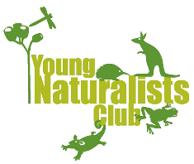

The Young Naturalists Club is open to children in Albany and surrounding areas who are between 5 and 15 years of age. Members attend events with at least one of their parents. We provide the group with at least 2 events per month (excluding school holidays) that centre around learning about, and caring for the environment.

Ethos

Awareness
Our club is about building awareness of environmental issues and threats and the programs and organizations in the Great Southern Region that conduct activities to address these issues and promote understanding and care for our environment.
We will become aware of the different ecologies within our own area and region.

Education
Through hands on participation in environmental activities we will learn about the local fauna, avifauna and flora.
By being guided by experts in many fields and others passionate about the environment in which we live, we will increase our knowledge in as many areas as possible.

Respect
We will show respect for our fellow members, experts and all those that we come in contact with at all times. We will foster and support a friendly environment where everyone will feel welcome. We are inclusive of people from all backgrounds who want to connect to the environment in a positive way.
We will show respect for the environment in all that we do.

Growth
We will work toward all those who participate in the Young Naturalists Club growing in ability, knowledge and social conscience.

Membership Costs

Includes backpack with goodies, member t-shirt and access to all events:

1 Child- $50 per year (Renewal $30)
2 Children $75 per year (Renewal $45)
3 or more children $100 per year (Renewal $60)

Contact

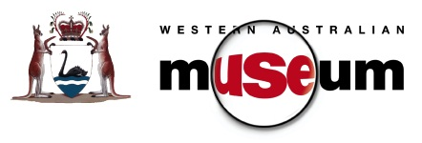
Peter Pritchard
Education Officer, WA Museum, Albany
ph: 9841 4844 email: Peter.Pritchard@museum.wa.gov.au

