WAM Drupal Publishing Guide

This is a brief guide to publishing web content for WAM through Drupal.

First Steps:
Login in via http://museum.wa.gov.au/user (using your supplied login details)

Once logged in, the two functions ‘Dashboard’ and ‘Workflow’ on the top black toolbar will allow you to create and edit pages. Go to ‘Dashboard.’

Adding Content:

Once you’ve gone to ‘Dashboard,’ your page will look like this:

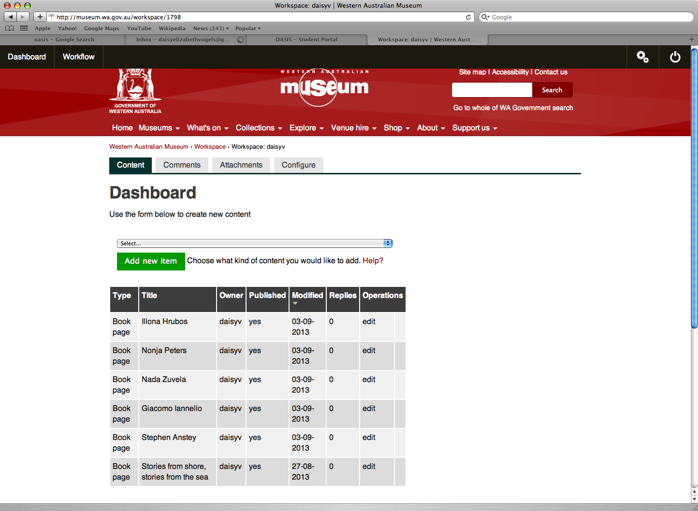

From here, select or create the page that you wish to add content to.
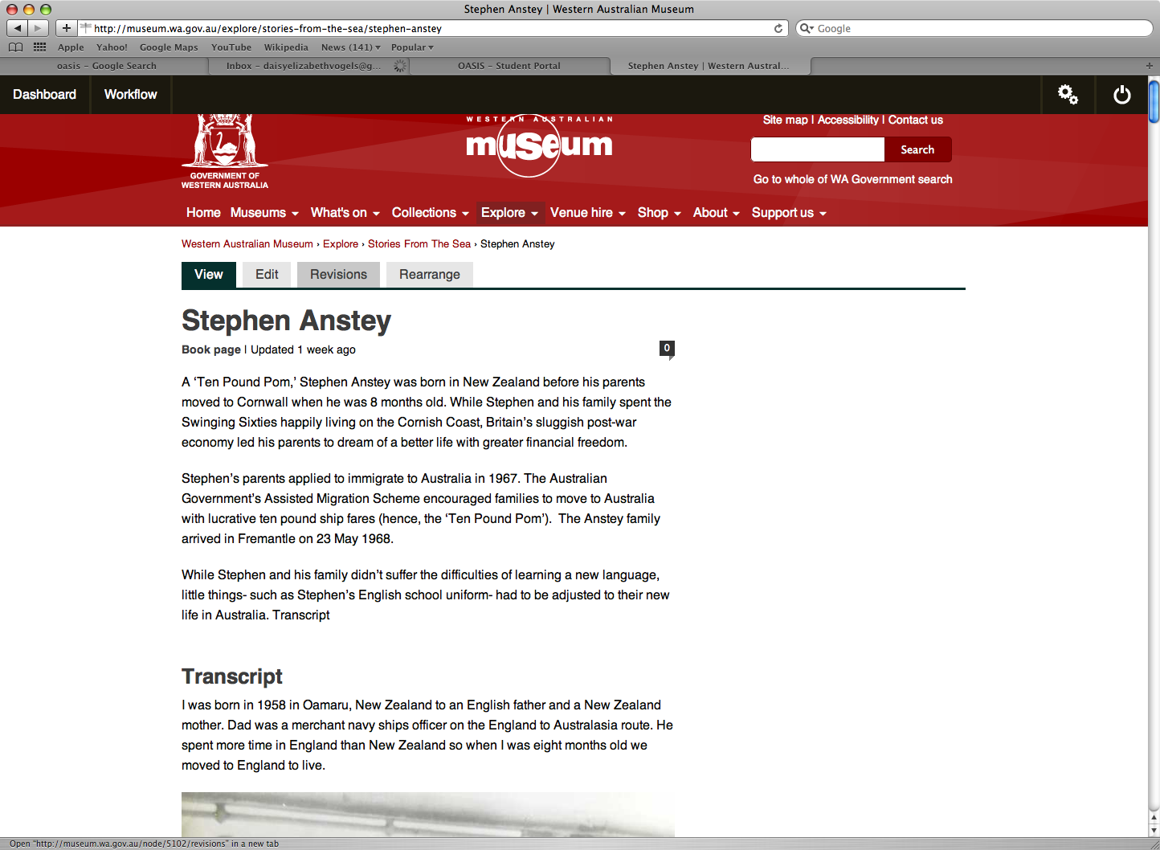

Adding text and creating headings

Once you have created and selected a page, click ‘edit.’ The ‘View,’ ‘Edit,’ ‘Revisions’ and ‘Rearrange’ buttons are located towards the top of the page, under the Museum banner. These will help you edit, view and keep track of changes throughout the publication and editing process.

The page will then look like this:

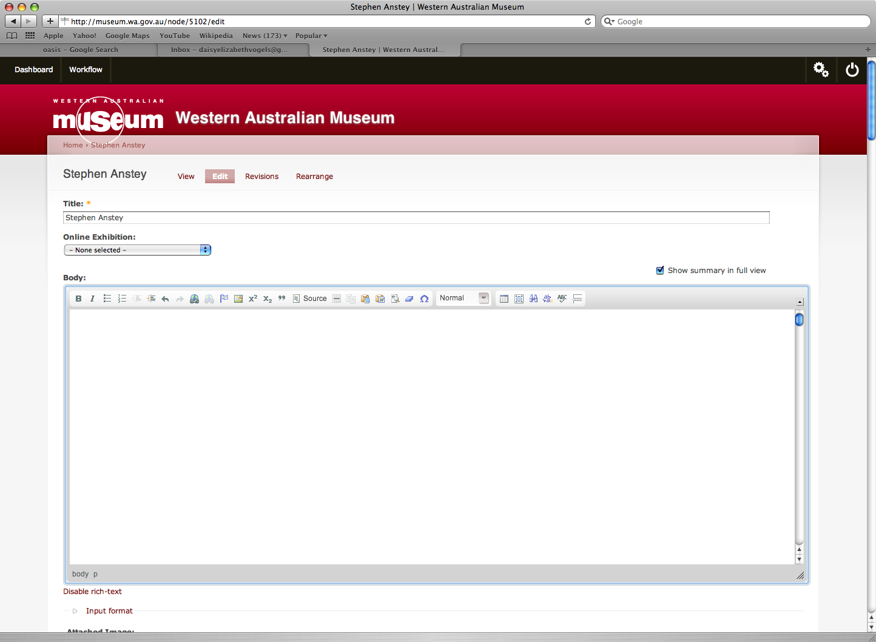

Now that you have selected ‘edit,’ you can…
- Write your title in the allocated ‘Title’ box
- Begin writing or pasting in text
- Upload images

Text:

Text can be written directly into the text box or copy and pasted in.
When pasting into the text box, select ‘Paste as plain text’ button located on the toolbar. This button is 12 from the right, next to the Word symbol.
When pasting text from Microsoft Word, click the ‘paste from word’ button.
If adding images, consider where you would like them to go, but there is no need to leave large spaces for them.

The font is automatically set to the Museum’s standard style.

‘WYSIWYG’ Toolbar

The top toolbar in the text box features a variety of buttons that allows you to alter your text.

Bold: To bold a word, highlight and press the ‘B’ or control B
Italics: To italicise text, highlight and press the ‘I’ or control I
Link: Use the ‘Link’ button on the toolbar to create a hyperlink.
Remove Format: If you are having any formatting issues, click the ‘remove format’ button to amend any styling issues, i.e. Non-standard font appearing when the page is ‘viewed.’

There are also various other functions on the toolbar, such as Tables, Spell Check, Find and Block quote.

Headings:

Headings and sub headings need to be distinguished by altering them to be either Heading 2, Heading 3 etc. depending on the nature of the heading (the title is classed as Heading 1). To make a word or title a heading, simply highlight it and select the correct heading from the toolbar above. This is shown below:

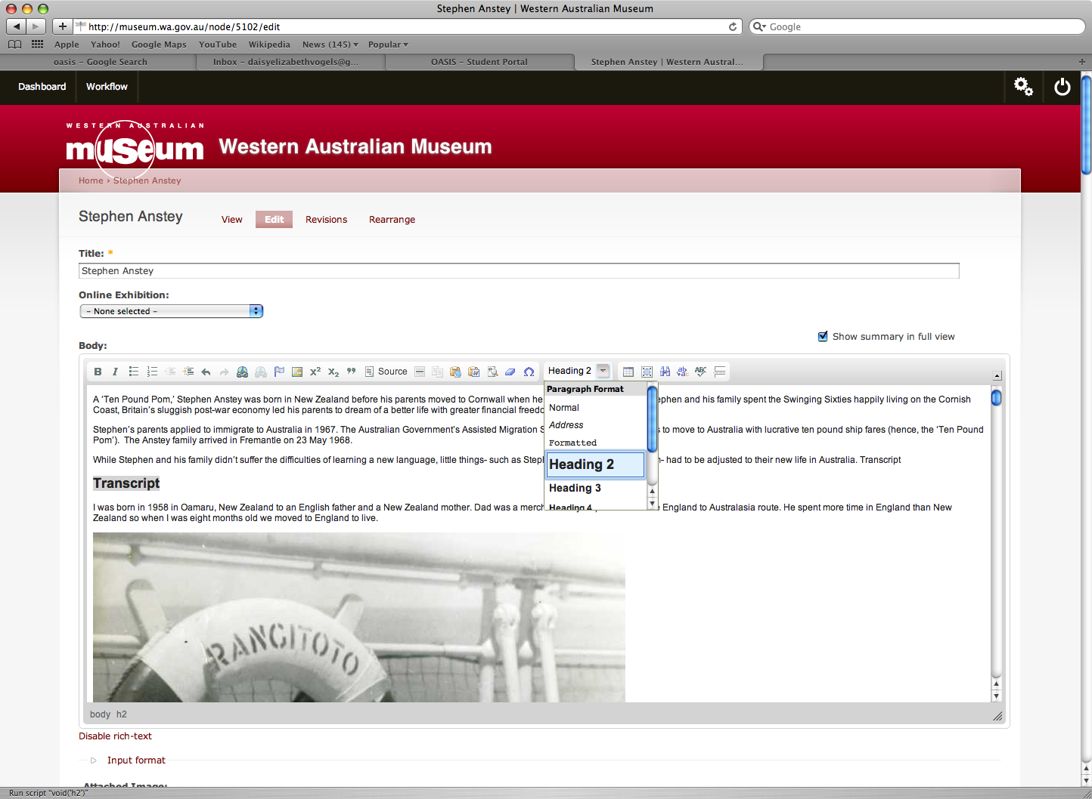

Images:

Images must be uploaded and then inserted into the text. To upload an image, scroll down to ‘Attached Image’ and select ‘Choose File.’ From here, select the image you wish to include in the document and click ‘choose.’

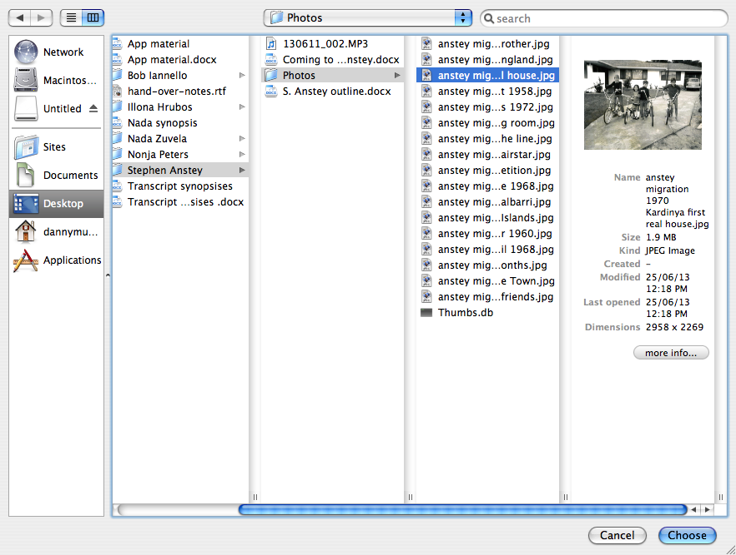

Once your image has been selected, click the ‘upload’ button directly to its right.
Once selected, the image area should appear like this, ready to add captions and adjust the image size:

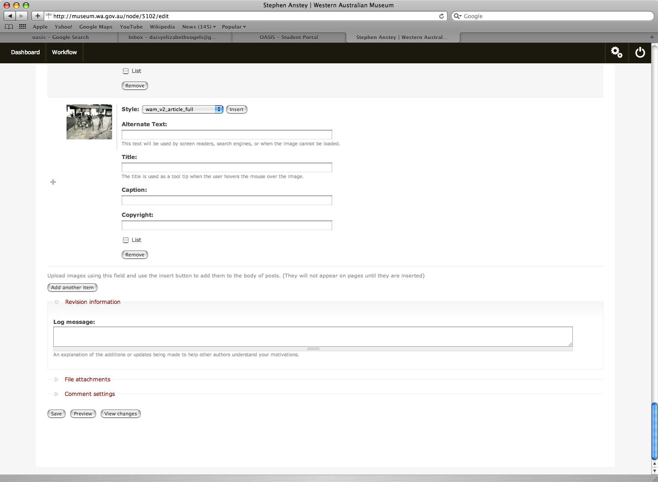

You will now need to adjust the following:
- Style
- Alternate Text
- Title
- Caption (not always necessary)

Style: Depending on whether your image is landscape or portrait, you will need to adjust the ‘style.’

If your image is landscape, adjust the style to wam_v2_article_full

If your image is Portrait, adjust the style to wam__v2_article_full_nocrop. If you don’t do this, the top and bottom of your image will be cropped out.

Alternate Text: In this box you will need to write a description of the image you’re uploading, with more detail than a regular caption. However, you will need to describe the image succinctly, yet effectively. This text is used by screen readers, search engines, and in the event that the image cannot load- so do not skip this step.

Title: In this box simply write the title of your image, for example: ‘Stephen and his brother, 1967’.

Example of Alternate Text versus Title:

Alternate Text: Stephen and his mother and siblings waving streamers on board the Fairstar.
Title: The Anstey family on board the Fairstar.

Caption: Here you can add additional information regarding the image, if you wish.

Inserting Images

Once you have completed adding your alternate text and title, locate where you want your image to go in the text. Once you have decided where you want your image to fit, select ‘insert.’ Make sure you are inserting the image into a blank line- inserting an image mid-sentence will separate it.

Note: If you make changes to the size, title or alternate text, you may need to re-insert the image for the changes to appear.

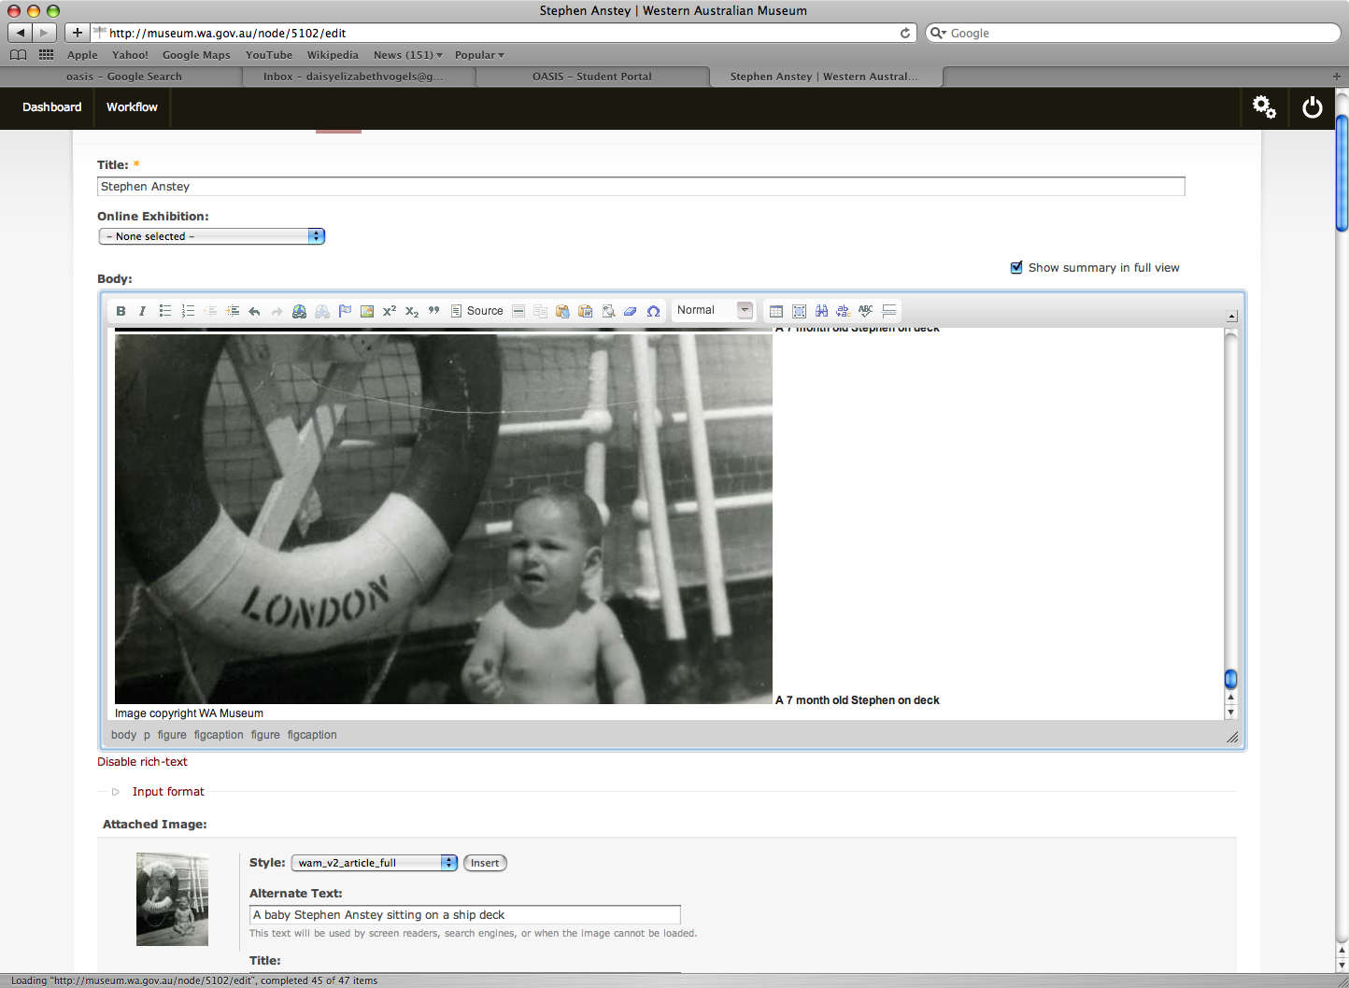

Copyright and Credits

Once you have inserted the image into your text box, ‘Image copyright WA Museum’ will automatically appear under the title. If your image does belong to the Museum, leave this as is. However, if your image has been outsourced, credit the image as appropriate. To edit this, simply deleted the automatically occurring text and rewrite the new credit.

For example, you may need to change ‘Image copyright WA Museum’ to ‘Image courtesy of Joe Bloggs.’

Note: Each time you reinsert an image, the credit will revert back to ‘Image copyright WA Museum,’ therefore you will need to edit it each time to ensure the image is appropriately credited.

Adding and Deleting Images

If you’re adding multiple images, you may need to click ‘add another image,’ which is located beneath the photos already uploaded. This will allow you to add more images in the same manner as before.

Editing Content

Editing content is very similar to adding content. This may include adding or deleting text and images. To return to the pages you’re working on or want to edit, always return to the ‘Dashboard.’

Inserted an image into the wrong area of text?

Easily fixed, simply hit ‘backspace’ or ‘delete’ and the image will disappear from the text. You will not need to re-upload the image as the image and captions will still be under the text box. Once you have found the correct place, simply insert the image again.

You can highlight the image and caption text or simply backspace the characters and image individually. See below: highlight and then delete.

Note: When you’re deleting the image and its credits and title, make sure you don’t accidentally delete any of your other written text. Always proofread your article again and again.

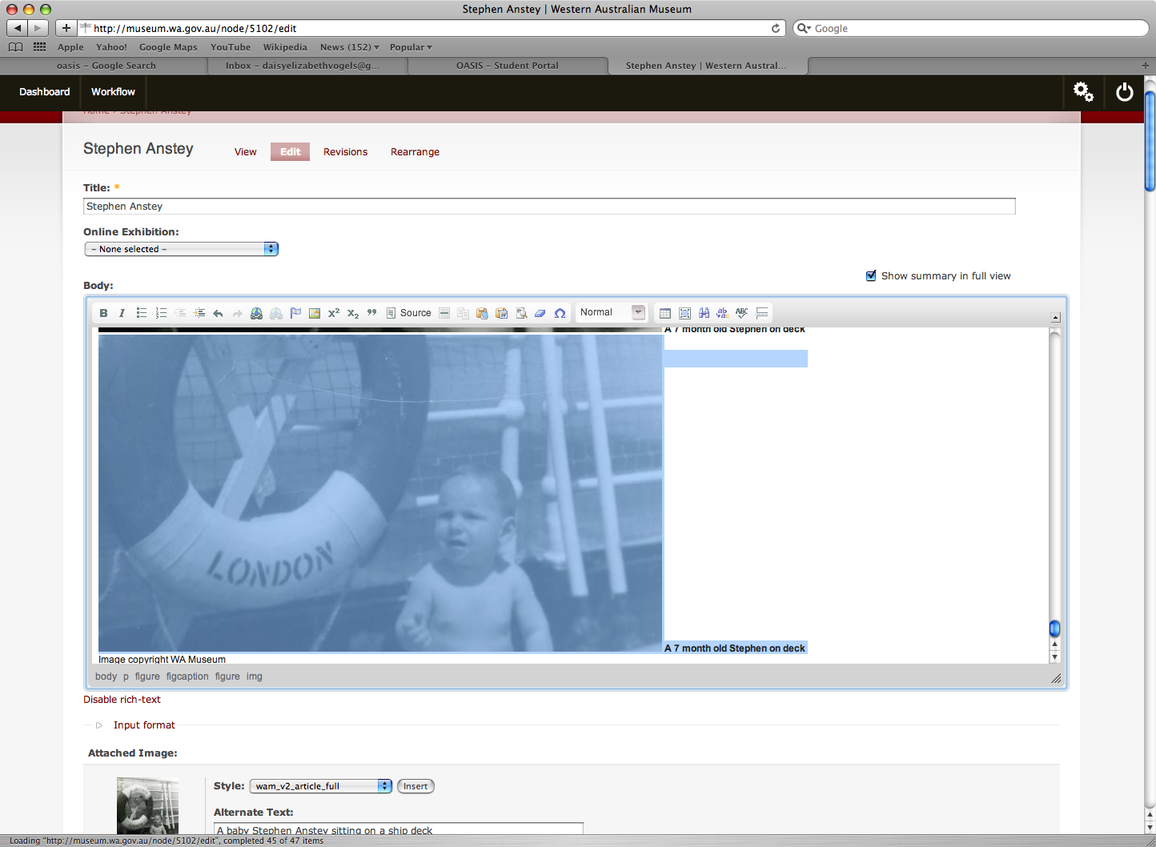

Changed your mind and no longer want to use a certain image at all?

If you don’t want to use an image that you have uploaded you have two options. You can choose not to re-insert the image immediately and leave the image and title for a later edit (where you may decide to use that image). OR, you can simply go down to the uploaded image and underneath the title and caption boxes click ‘remove.’ This will delete the uploaded image and you will have to re-upload it if you want to insert it into your text.

Editing and Saving Text

To change your text, simply add or deleted as you would normally. Once you have finished adding your text and images, you can choose to either ‘preview’ or ‘save.’

Preview:

Clicking ‘preview’ will give you an indication of spacing and formatting issues, and you may need to make small changes. Alternatively, you may want to change the layout of some images and text or change the image’s title.

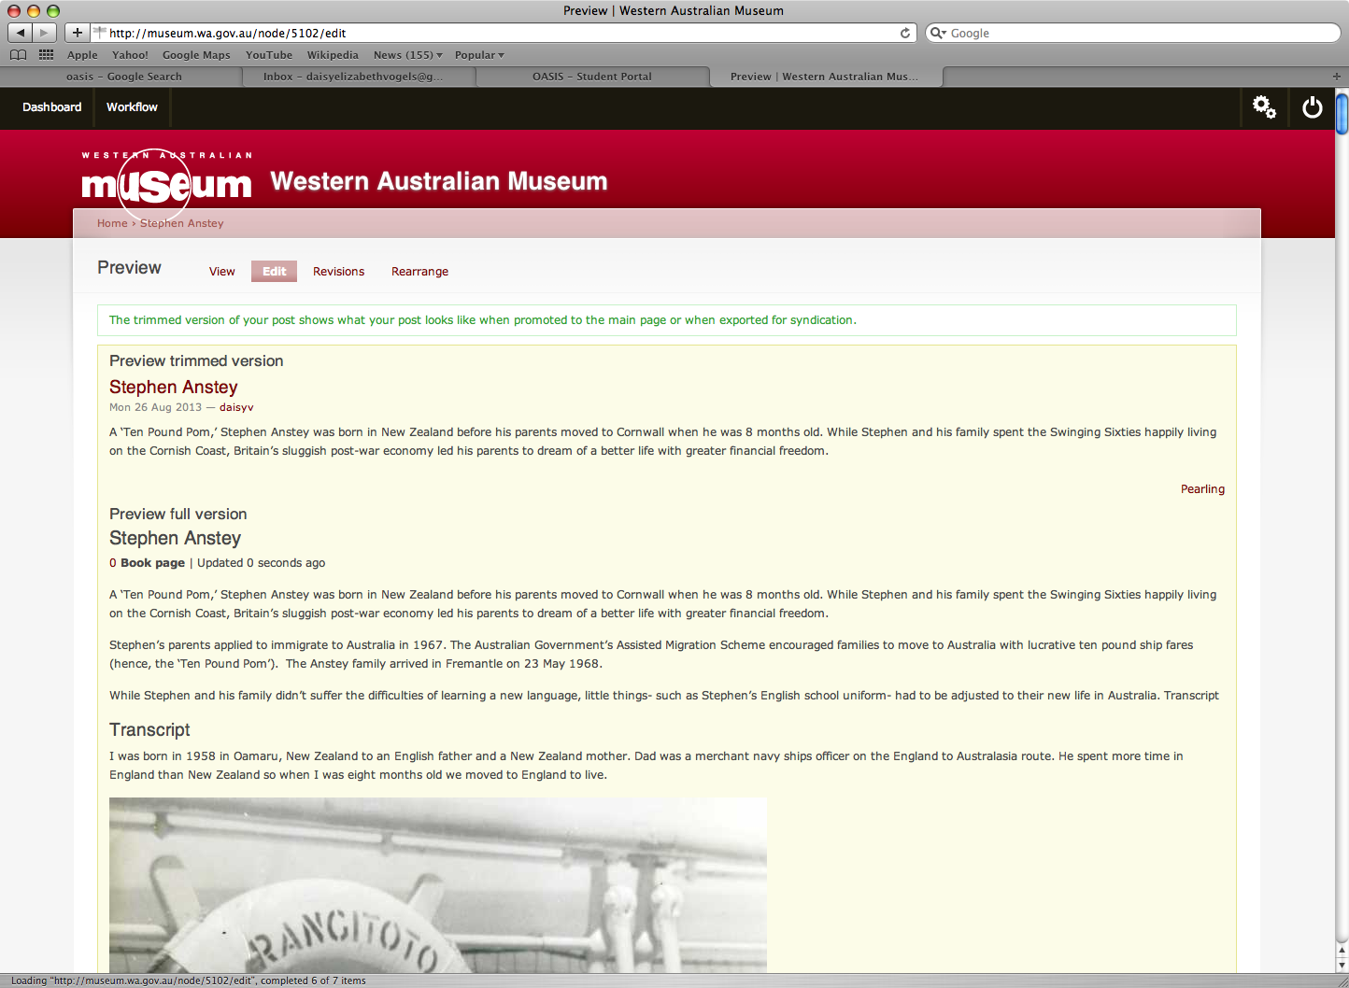

View:

Clicking ‘view’ will take you to a ‘finalised’ (but not live) version of the text. The first ‘save’ of the page will need to be authorised by the site admin before the page goes live.
However, clicking ‘view’ will still give you a good idea of how the text will appear online- you will need to proofread thoroughly and edit any spacing issues. Furthermore, ensure that the ‘i’ box- which is clicked for more information- is on the bottom left hand corner of every image (it will appear when the page is being viewed). If it is not, ensure you have written a title for the image and try re-uploading the image.

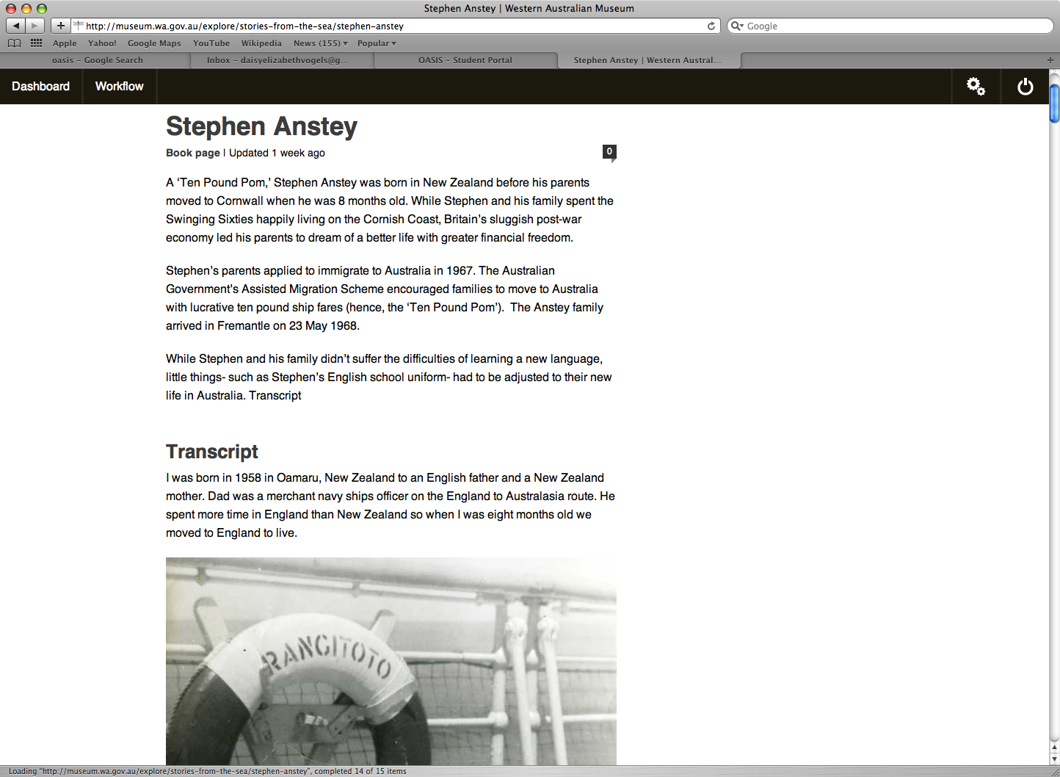

Save:
After you’ve added text and images, hit ‘save’ to ensure you don’t lose any work.

Publishing checklist
- Proofread and edit thoroughly
- Ensure credits and copyright captions are correct (spelling of names, too!)
- Make sure the text’s grammar and spelling is in accordance with the WAM style guide (for online).
- Ensure you have selected the correct ‘style’ for your image.

